***Use Case Diagram for An Online Voting System***

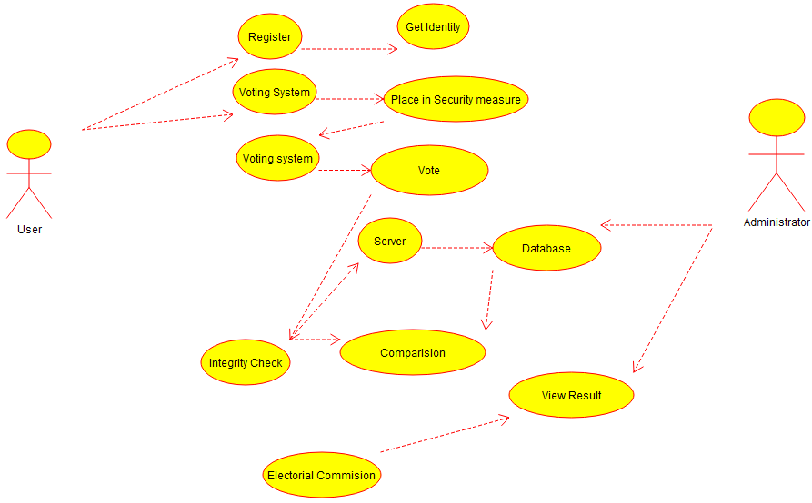

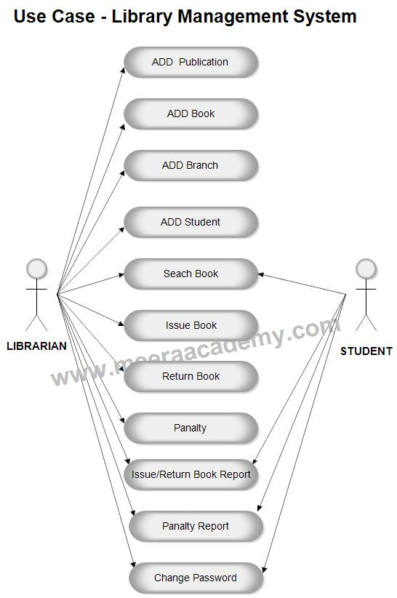

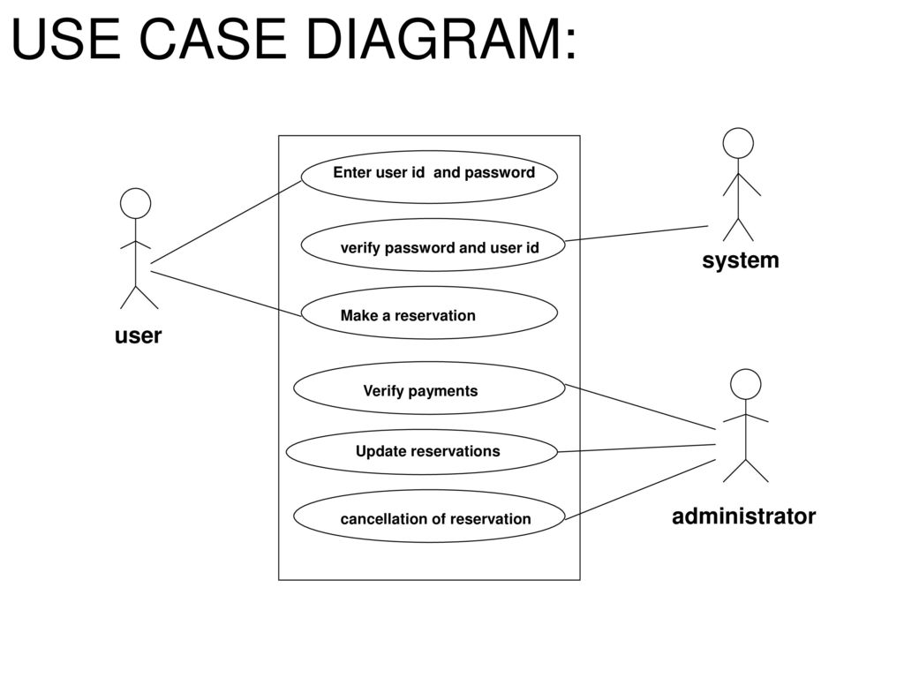

**Use Case Diagram for Hospital Management System**

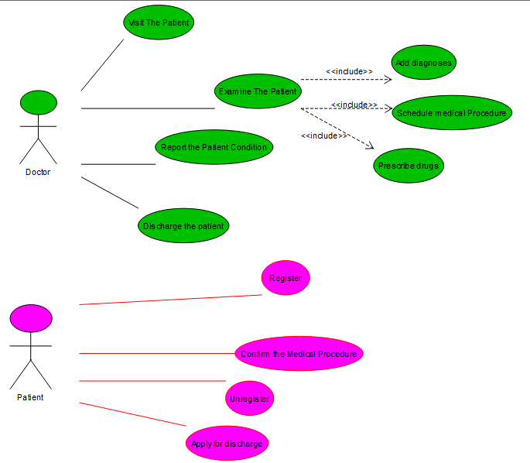

**Use Case Diagram for ATM System**

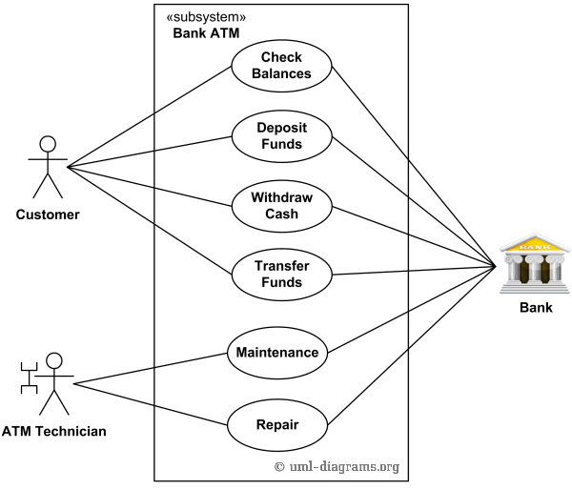

**Use Case Diagram for Online College Management System**

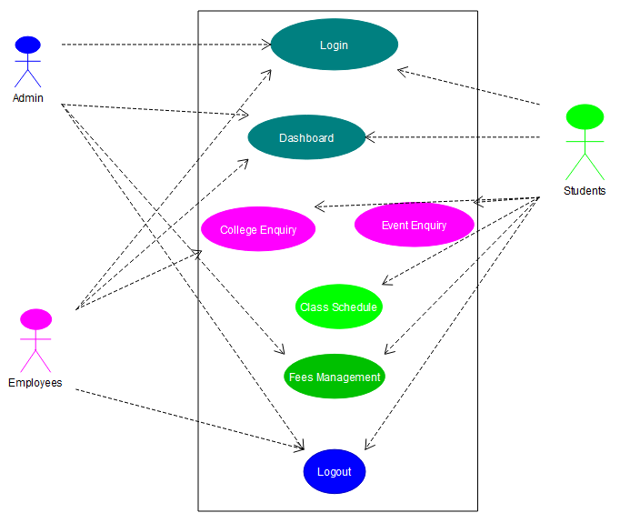

**Use Case Diagram for Restaurant Systems**

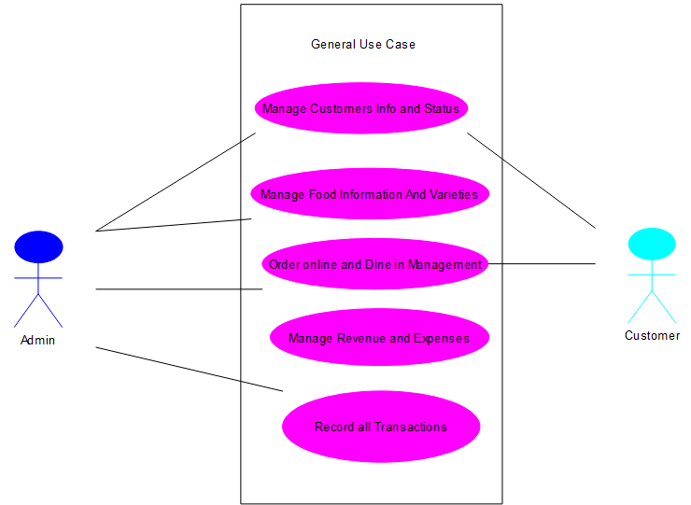

**Use Case Diagram for Quiz System**

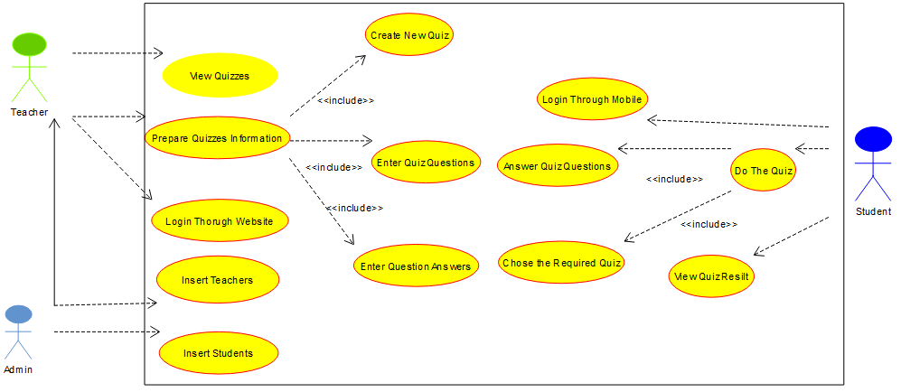

**Use Case Diagram for Online Airline Reservation System**

